Cryptocurrency Matching Engine
- Introduction
The Cryptocurrency Matching Engine is a high-performance backend component designed to simulate and execute cryptocurrency trades. It supports multiple order types such as LIMIT, MARKET, IOC, and FOK, following price-time priority similar to traditional exchange systems. The engine is built using Python with FastAPI for REST API handling and WebSocket for real-time market data dissemination.
- System Architecture
The system is structured around modular components to ensure clarity, scalability, and ease of maintenance.:
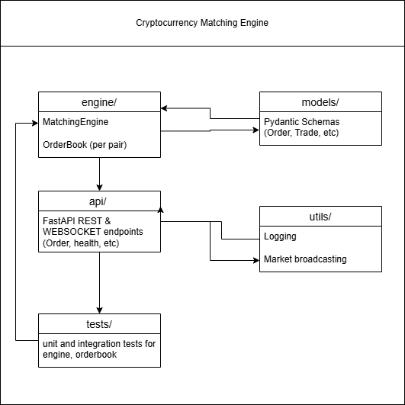
Each trading symbol (e.g., BTC-USDT) has a distinct OrderBook object managed by the MatchingEngine. This separation ensures independent order processing and symbol isolation.
- Data Structures
The order book leverages efficient data structures for performance:
SortedDict: Maintains ordered price levels for bids (descending) and asks (ascending).
Deque: Preserves FIFO time-priority within price levels.
Order_map: Provides constant-time access for order lookup/removal.
List: Stores completed trades for retrieval and history tracking.

- Matching Algorithm
The matching algorithm follows price-time priority, ensuring fairness and determinism in order execution. When an order arrives, it is matched against the opposing order book:
BUY orders match with the lowest ask prices.
SELL orders match with the highest bid prices.
The algorithm supports partial fills, full executions, and residual order handling based on order type:
LIMIT: Rests remaining quantity on the book.
MARKET: Executes immediately; unfilled quantity is discarded.
IOC: Executes immediately and cancels leftover.
FOK: Executes fully or cancels entirely.
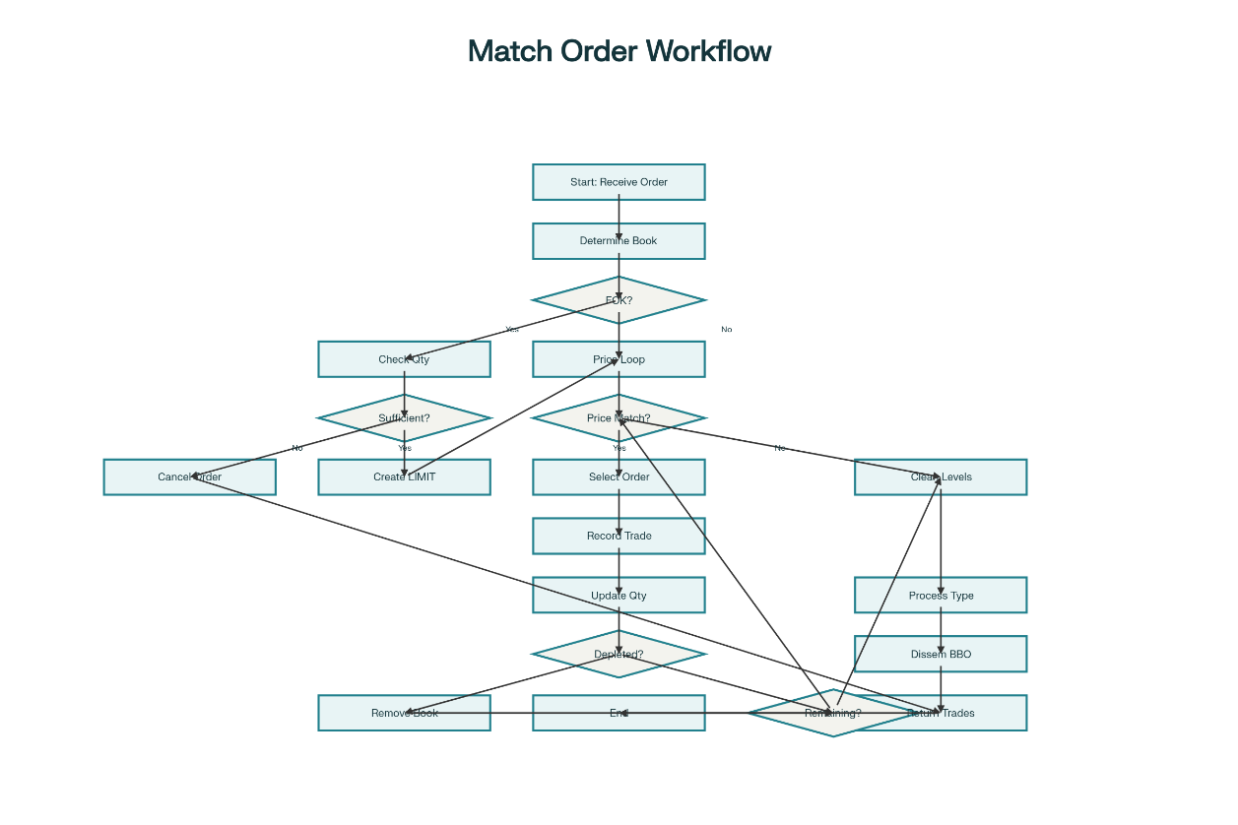

API Specifications
The engine exposes REST and WebSocket APIs for client interaction:

REST Endpoints
GET /appV1/health — Returns server status.
POST /appV1/orders — Submits a new order. Requires an Order schema payload:
{
"symbol": "BTC-USDT",
"side": "BUY",
"type": "LIMIT",
"price": 62000,
"quantity": 1
}
A successful response returns the trade executions (if any) and order placement confirmation.

WebSocket Broadcasts
The engine uses WebSocket channels to push live market updates:
Market Data Stream (/wsV1/marketdata): Sends BBO (Best Bid/Offer) updates.
Trade Stream (/wsV1/trades): Publishes all executed trades with full attribution.
Broadcasts occur only when the market state changes.

Design Trade-offs
Performance vs. Readability: The system prioritizes clarity over micro-optimizations, using Python’s high-level data structures.
Feature Scope: Focused on foundational order types for educational and prototype-level use.
Stateless Matching: Each order book operates independently per symbol.
Broadcast Efficiency: BBO dissemination occurs only on state change, reducing noise.

Testing and Validation
The `tests/` module includes automated test cases that validate:
Order addition and removal.
Correctness of matching logic.
Partial and full order executions.
BBO broadcast behavior.

